[Software Testing Help](http://www.softwaretestinghelp.com/" \o "Software Testing Help)

Top of Form

 

Bottom of Form

← [Why Software Testing Needs Revolution? (and Here is How)](http://www.softwaretestinghelp.com/why-software-testing-needs-revolution/)

[The Best Questions Testers Should Ask an Interviewer](http://www.softwaretestinghelp.com/the-best-questions-testers-should-ask-an-interviewer/) →

**5 Best Automation Tools for Testing Android Applications**

Posted In | [Automation Testing](http://www.softwaretestinghelp.com/category/automation-testing/), [Mobile Testing](http://www.softwaretestinghelp.com/category/mobile-testing/), [Software Testing Tools](http://www.softwaretestinghelp.com/category/software-testing-tools/) | Last Updated: "June 26, 2015"

Nowadays automated tests are used during almost every testing process. This is not surprising, as properly organized automated testing greatly reduces time needed for a testing process, excludes errors and omissions in tests execution caused by a human factor.

There is a wide choice of [tools for automation](http://www.softwaretestinghelp.com/category/software-testing-tools/" \o "Automation testing tools). Some of them are free, some are rather expensive. Some automation tools were created years ago; some have just appeared on the market. Each tool is unique and possesses certain characteristics.

Wide choice of available automation tools makes it difficult to select the most suitable ones for a project. The problem is that hardly any of the existing tools fully corresponds to project requirements.

[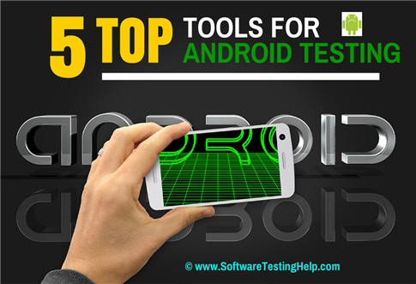](http://cdn2.softwaretestinghelp.com/wp-content/qa/uploads/2014/07/Top-Android-Testing-Tools.jpg)

**In Order to Make Automated Tests Effective and Profitable One Should:**

* Research the software product under test and the project;
* Clearly determine what tests are to be automated;
* Formulate requirements to the automated tests and the tools for automation;
* Study at least several available and more or less suitable tools for automation;
* Select the most suitable one or more tools basing on the researches;
* Discuss the chosen automation tools with other project parties, explain the choice, and get their approval;
* Proceed to tests automation.

Such approach and sequence of steps would be approved by most of quality assurance experts.

Many different kinds of computers have appeared recently, their appearance started rapid development of software products. The most amazing is evolution of mobile devices; they significantly differ from common personal computers by characteristics, ways and conditions of interaction with them.

Consequently, smartphones and tablets require special mobile applications that differ from desktop ones.

Operating system of most of personal computers is Windows. Among popular mobile operating systems are Android, Apple iOS, Blackberry OS, Windows Phone, Symbian and other.

**Also read => [Beginner’s Guide to Mobile Application Testing](http://www.softwaretestinghelp.com/beginners-guide-to-mobile-application-testing/" \o "Mobile application testing guide)**

**Top 5 Android Testing Tools:**

*Let’s explore modern tools for automated testing of applications supported on one of the most widespread mobile operating system – Android.*

**#1. [Robotium Android Testing Tool](http://www.softwaretestinghelp.com/robotium-tutorial-android-application-ui-testing-tool/" \o "Robotium Android UI Testing Tool)**

***(Click to enlarge image)***

[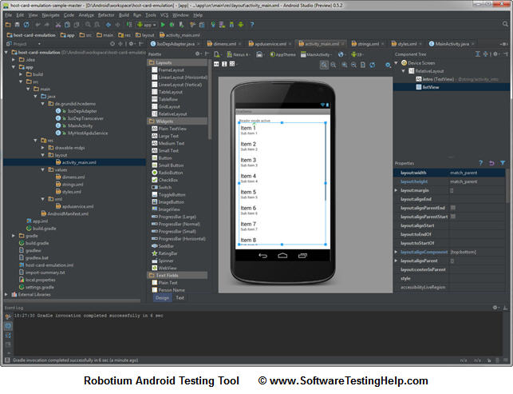](http://cdn2.softwaretestinghelp.com/wp-content/qa/uploads/2014/07/Robotium-Android-Testing-Tool.jpg)

**Robotium is one the first and frequently utilized automated testing tools for software supported on Android.**

Robotium is a free Android UI testing tool. It is suitable for tests automation for different Android versions and sub-versions. Software developers often describe it as Selenium for Android. Tests created by Robotium are written in Java. In fact, Robotium is a library for unit tests.

But it takes much time and efforts to create tests by means of Robotium, as one must work with the program source code in order to automate tests. The tool is also unsuitable for interaction with system software; it cannot lock and unlock a smartphone or a tablet. There is no Record and Play function in Robotium, and it does not provide screenshots.

**#2. [MonkeyRunner](http://developer.android.com/tools/help/monkeyrunner_concepts.html" \o "MonkeyRunner Android testing" \t "_blank) Android App Testing**

[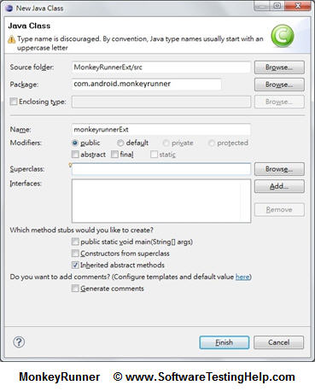](http://cdn.softwaretestinghelp.com/wp-content/qa/uploads/2014/07/MonkeyRunner-Android-App-Testing.jpg)

**MonkeyRunner is one of popular Android Testing tools used for automating of functional tests for Android software.**

This tool is more low-level than Robotium is. One does not have to deal with the source code in order to automate tests. The tests are written in Python, one may use a recording tool for creating tests.

MonkeyRunner can run tests on real devices connected to a PC or emulators. The tool has an API what allows it to control a smartphone, a tablet or an emulator from outside of Android code.

Significant disadvantage of the mobile app testing tool is that it is necessary to write scripts for each device. Another problem of MonkeyRunner is that the tests require adjustments each time when user interface of the tested program is changed.

**#3. [Ranorex](http://www.ranorex.com/" \o "Ranorex mobile app testing" \t "_blank)Android Application Testing Tool**

***(Click to enlarge image)***

[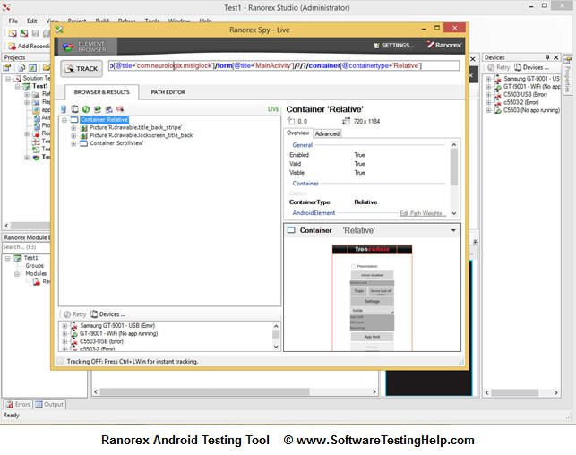](http://cdn.softwaretestinghelp.com/wp-content/qa/uploads/2014/07/Ranorex-Android-Testing-Tool.jpg)

Ranorex is a good tool for tests automation not only for the latest, but also for early versions and sub-versions of Android, beginning from Android 2.2.

One of Ranorex advantages is its detailed reports with screenshots. It can connect a smartphone or a tablet to Internet via WiFi.

An automated test engineer can elaborate data-driven tests, excluding XML data format, by means of this Android tool. Ranorex Studio enables an automated test engineer to create tests easily, just clicking the mouse. It allows elaborating additional program modules. The modules may be utilized during late development cycles for more complex test scenarios.

It is a commercial mobile application tool; its license price is 1990 EUR. Ranorex searches elements rather slowly; it takes up to 30 seconds to perform such an operation. One must instrument APK files for Ranorex. Otherwise it is impossible to automate tests by means of this tool, as it works only with instrumented APK files.

------------

**#4. [Appium](http://appium.io/" \o "Appium app testing tool" \t "_blank) Android Automation Framework**

***(Click to enlarge image)***

[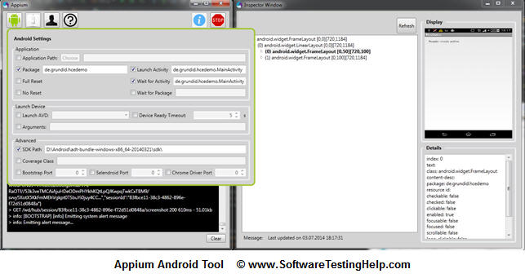](http://cdn2.softwaretestinghelp.com/wp-content/qa/uploads/2014/07/Appium-Android-Automation-Framework.jpg)

It’s a framework for creation automated tests for iOS and Android. It is a free tool. It supports Android versions from 2.3 and later. Appium utilizes WebDriver interface for tests running. It supports many programming languages, such as Java, C#, Ruby and other which are in the WebDriver library.

It can control Safari and Chrome on mobile devices. This allows to test mobile web sites using Appium and these browsers.

But some automated test engineers complain that it provides poor, insufficient reports. Also its weakness is reduced XPath support on mobile devices.

**#5. [UI Automator](http://developer.android.com/tools/help/uiautomator/index.html" \o "UIAutomator for Android Test Automation" \t "_blank) for Android Test Automation**

***(Click to enlarge image)***

[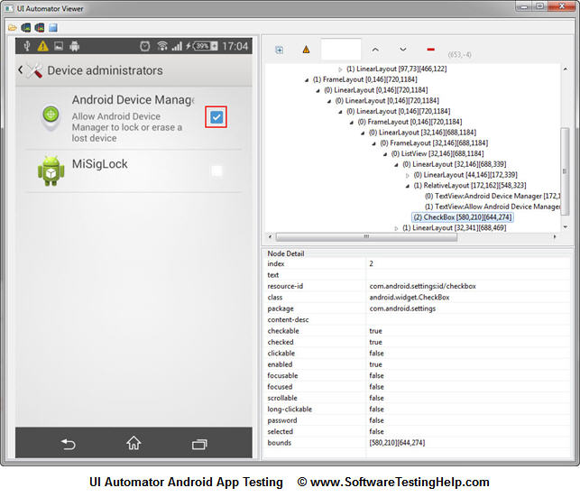](http://cdn.softwaretestinghelp.com/wp-content/qa/uploads/2014/07/UI-Automator-for-Android-Test-Automation.jpg)

This tool has been recently elaborated by Google. It supports Android versions beginning from 4.1. One should select another Android app testing tool in order to automate tests for earlier versions. UI Automator is able to interact with all kinds of software products for Android, including system applications. This enables UI Automator to lock and unlock a smartphone or a tablet.

Scripts created by means of this tool can be executed on many different Android platforms. It allows reproducing complex sequences of user actions.

UI Automator also can utilize external buttons of a device, such as buttons for going back, volume regulation, turning on and off the device.

It can be integrated with testing framework TestNG. In this case UI Automator can generate informative and detailed reports, similar to reports generated by Ranorex. This tool also searches elements very fast.

Software testing experts find UI Automator good for quality mobile application testing on many Android platforms. It is one of the best tools for Android applications, as it is elaborated by Google specially for this operating system.

Usually about 80% of new software bugs reproduce on all the supported platforms. So, one may perform **mobile testing** on one of widely used platforms and discover up to 80% of defects. The rest 20% will be found on all the other platforms. That means that in most cases it is better to test software product thoroughly on fewer platforms than hastily on numerous.

At present Android 4.1 is installed on about 66% of all devices using Android operating system. That is why many automated test engineers often decide that UI Automator is the most suitable solution.

**Ranorex is frequently utilized for creation tests for early Android versions.**

**Conclusion:**

Tests automation is a complex task. It requires thorough preparation and researches. One should also keep up with all the novelties in information technology, applications and test automation tools. All this knowledge is necessary for creating the most effective tests.

***About the Author:*** *This is a guest post by Oleg Prosyanik, a Senior Automated Test Engineer of [QATestLab](http://qatestlab.com/" \o "http://qatestlab.com/" \t "_blank), a leading Ukrainian company offering full range of software testing services. He has been automating tests for more than 4 years. Oleg creates automated tests for different desktop and mobile applications; he has strong programming skills in widely used languages, such as Java, PHP, Delphi, Ruby, C#.*

***Let us know if you have any queries on mobile testing or Android Testing Tools we listed in this article.***

91  
[inShare](javascript:void(0);)

[34](http://www.softwaretestinghelp.com/5-best-automation-tools-for-testing-android-applications/" \l "respond)

**Recommended Reading Only For You:**

• [Web Application Load, Stress and Performance Testing Using WAPT](http://www.softwaretestinghelp.com/web-application-load-stress-and-performance-testing-using-wapt/" \o "Web Application Load, Stress and Performance Testing Using WAPT)

• [Want to Stress Test Website with 10,000+ Users? Use WAPT Pro x64 Load Engine](http://www.softwaretestinghelp.com/wapt-pro-x64-load-engine-performance-testing-tool/" \o "Want to Stress Test Website with 10,000+ Users? Use WAPT Pro x64 Load Engine)

• [HP Quality Center Tutorials – Learn HP ALM/QC in 7 Days](http://www.softwaretestinghelp.com/learn-hp-quality-center-qc-in-4-days/" \o "HP Quality Center Tutorials – Learn HP ALM/QC in 7 Days)

• [How to Performance Test an Application – LoadRunner Training Tutorial Part 2](http://www.softwaretestinghelp.com/how-to-performance-test-an-application-loadrunner-training-tutorial-part-2/" \o "How to Performance Test an Application – LoadRunner Training Tutorial Part 2)

• [How to Create and Execute Your First SoapUI Project Using WSDL – SoapUI Tutorial #4](http://www.softwaretestinghelp.com/soapui-tutorial-4-working-with-soapui-projects/" \o "How to Create and Execute Your First SoapUI Project Using WSDL – SoapUI Tutorial #4)

• [Understanding Assertions in SoapUI – SoapUI Tutorial #5](http://www.softwaretestinghelp.com/soapui-tutorial-5-soapui-assertions/" \o "Understanding Assertions in SoapUI – SoapUI Tutorial #5)

• [How to Write Basic Groovy Script in SoapUI – SoapUi Tutorial #6](http://www.softwaretestinghelp.com/soapui-tutorial-6-write-groovy-script-in-soapui/" \o "How to Write Basic Groovy Script in SoapUI – SoapUi Tutorial #6)

**The Best Software Testing Training You'll Ever Get!**

[](http://www.softwaretestinghelp.org/)

**34 comments ↓**

[#1](http://www.softwaretestinghelp.com/5-best-automation-tools-for-testing-android-applications/" \l "comment-101920" \o "Permalink to this comment) **Aparna**

Nice article…thank u

[#2](http://www.softwaretestinghelp.com/5-best-automation-tools-for-testing-android-applications/" \l "comment-101921" \o "Permalink to this comment) **smita**

can you compare which is best for what? I mean Robotium for UI testing etc..

[#3](http://www.softwaretestinghelp.com/5-best-automation-tools-for-testing-android-applications/" \l "comment-101922" \o "Permalink to this comment) **kishore**

nice updates regarding testing employees

[#4](http://www.softwaretestinghelp.com/5-best-automation-tools-for-testing-android-applications/" \l "comment-101924" \o "Permalink to this comment) **udara**

Is it need to know the language, which is develop mobile application, to use above mention tools, to test developed mobile application?

[#5](http://www.softwaretestinghelp.com/5-best-automation-tools-for-testing-android-applications/" \l "comment-101928" \o "Permalink to this comment) **anu**

very informative…..  
Thanks

[#6](http://www.softwaretestinghelp.com/5-best-automation-tools-for-testing-android-applications/" \l "comment-101934" \o "Permalink to this comment) **Sandra**

Hi

Thanks for the (as always) informative article.  
I would add the SeeTest tools from Experitest (www.experitest.com) to this list.

It supports Android devices securely- no need for rooting, works mainly through native object identification methods (most reliable as not sensitive to UI differences), integrative with test environments and CI frameworks, can run same test on different devices, easy to use. I’ve used it time and time again and am very pleased with this tool. Highly recommended.

[#7](http://www.softwaretestinghelp.com/5-best-automation-tools-for-testing-android-applications/" \l "comment-101939" \o "Permalink to this comment) **Vishnu More**

Helpful Article…

Thanks..!!

[#8](http://www.softwaretestinghelp.com/5-best-automation-tools-for-testing-android-applications/" \l "comment-101944" \o "Permalink to this comment) **Arun Kumar**

Hi All,

Send your resume to my email id [arunz550i@gmail.com](mailto:arunz550i@gmail.com). Need candidate for below requirement with more than 3.5 years experience:

1. Functional testing.  
2. ETL testing – ab initio  
3. ETL testing – informatica  
4. Selenium tool.

Address:  
DOB:

Thanks  
ArunKumar

[#9](http://www.softwaretestinghelp.com/5-best-automation-tools-for-testing-android-applications/" \l "comment-101946" \o "Permalink to this comment) **prema**

Really appreciate… very helpful…Thank you so much..

[#10](http://www.softwaretestinghelp.com/5-best-automation-tools-for-testing-android-applications/" \l "comment-101948" \o "Permalink to this comment) **Ava Rivard**

Now I study automated testing tools for my project and this article is really helpful for me.

[#11](http://www.softwaretestinghelp.com/5-best-automation-tools-for-testing-android-applications/" \l "comment-101966" \o "Permalink to this comment) **Sachin**

Hi..  
Simple Question –

I am Manual Tester, and now if i want to learn Automation then what will be first step :  
Learn the Tool i am going to work on ?  
or  
Learn the Language (programming) on which tool works ?

Please elaborate answer ..I will appreciate if you explains more in detail.

[#12](http://www.softwaretestinghelp.com/5-best-automation-tools-for-testing-android-applications/" \l "comment-101971" \o "Permalink to this comment) **siddhant**

finally i came to understand how to select automation tool…..  
very helpful.  
thank you… 

[#13](http://www.softwaretestinghelp.com/5-best-automation-tools-for-testing-android-applications/" \l "comment-101974" \o "Permalink to this comment) **Oleg Prosyanik**

Hi all!  
Nice to see you like my article.

Udara,  
you shouldn’t know the language, your software for testing written. Android applications written on Java. Automated tests can be written on Java, C#, Python, Ruby etc. Programming language depends on automation tool you use.

[#14](http://www.softwaretestinghelp.com/5-best-automation-tools-for-testing-android-applications/" \l "comment-101976" \o "Permalink to this comment) **Oleg Prosyanik**

Hi, Sachin.  
It’s better to study programming language first. You should know main features of language you’ve chosen, know code style etc. After that start to develop automated tests, which use frameworks exactly for your tool.

[#15](http://www.softwaretestinghelp.com/5-best-automation-tools-for-testing-android-applications/" \l "comment-102421" \o "Permalink to this comment) **Vigneshwaran**

Mobitaz (<http://www.msys-tech.com/mobitaz/>) is missing in this list.

Please check with Mobitaz, testing tool intended for Native and Hybrid Android apps.

[#16](http://www.softwaretestinghelp.com/5-best-automation-tools-for-testing-android-applications/" \l "comment-102740" \o "Permalink to this comment) **[Razia Sultana](http://www.webqit.com/)**

It is very very helpful for testers. Tnx

[#17](http://www.softwaretestinghelp.com/5-best-automation-tools-for-testing-android-applications/" \l "comment-102958" \o "Permalink to this comment) **Rohit**

Good summary on mobile testing you have provided.  
How about perfecto and Deviceanywhere they are also promising tool. any comment ?

[#18](http://www.softwaretestinghelp.com/5-best-automation-tools-for-testing-android-applications/" \l "comment-103674" \o "Permalink to this comment) **chandru**

Nice article and it was more informative.. Thanks.. 

[#19](http://www.softwaretestinghelp.com/5-best-automation-tools-for-testing-android-applications/" \l "comment-105561" \o "Permalink to this comment) **Gaurav Gupta**

Good summary on mobile app automation testing.Nice article.  
I would like to add one more in this list i.e. mAutomate.  
Used for automation testing of Android and IOS platform applications and for native, hybrid and web applications.  
For more info see [http://www.mautomate.com](http://www.mautomate.com/)

[#20](http://www.softwaretestinghelp.com/5-best-automation-tools-for-testing-android-applications/" \l "comment-122432" \o "Permalink to this comment) **gaurav khanna**

hope this may be helpful. Dont mind.

[#21](http://www.softwaretestinghelp.com/5-best-automation-tools-for-testing-android-applications/" \l "comment-132437" \o "Permalink to this comment) **Ila Garg**

Hi….  
MY Quesion:

I am a manual tester now i want to increase my knowledge in testing field so i want to know which is more useful database testing or mobile testing ?

[#22](http://www.softwaretestinghelp.com/5-best-automation-tools-for-testing-android-applications/" \l "comment-134040" \o "Permalink to this comment) **[syed mehtab](http://sourceforge.net/projects/uiautomator/)**

Nice article. I would like to add uiautomator-bot to the list. Its an open source tool for automating your UIautomator testing.

For more info check : [http://uiautomator-bot.blogspot.com](http://uiautomator-bot.blogspot.com/)

[#23](http://www.softwaretestinghelp.com/5-best-automation-tools-for-testing-android-applications/" \l "comment-134060" \o "Permalink to this comment) **Rishabh**

Our organisation is planning to introduce an Automation testing tool for our Mobile applications onAndroid and iOS platforms. What are we currently looking for is :

1. Cross- Platform support.  
2. Easy to use and create scripts (Record and play preferable)  
3. Better Online/Vendor support.

Please suggest a tool that is the best suitable for our needs. We are open to Licensed tools as well.

[#24](http://www.softwaretestinghelp.com/5-best-automation-tools-for-testing-android-applications/" \l "comment-169220" \o "Permalink to this comment) **Chandan**

Can you please tell me which is very usefull in automating android application.It should be open source.

[#25](http://www.softwaretestinghelp.com/5-best-automation-tools-for-testing-android-applications/" \l "comment-176011" \o "Permalink to this comment) **darryH**

Great article. I’d also highly recommend that you take a look at this list <http://codecondo.com/10-best-frameworks-for-mobile-app-testing/> which has top frameworks for App testing

[#26](http://www.softwaretestinghelp.com/5-best-automation-tools-for-testing-android-applications/" \l "comment-178357" \o "Permalink to this comment) **Manish Sharma**

Hi..

I am Manual Tester, and now if i want to learn Automation then what will be first step :  
Learn the Tool i am going to work on ?  
or  
Learn the Language (programming) on which tool works ?

Please elaborate answer ..I will appreciate if you explains more in detail.

[#27](http://www.softwaretestinghelp.com/5-best-automation-tools-for-testing-android-applications/" \l "comment-179400" \o "Permalink to this comment) **[Abhijeet](http://g33ktricks.blogspot.com/)**

Thanks Oleg for the nice article.

And  
@Manish: I would suggest to learn the Programming language instead of learning tool. Learning any tool as very easy which can be accomplished at any time. But a Language needs much of your attention. If any language is known to you, you will find it easy to understand how a tool works to get a most of it.  
Hope that helps!!!

[#28](http://www.softwaretestinghelp.com/5-best-automation-tools-for-testing-android-applications/" \l "comment-189664" \o "Permalink to this comment) **karthik**

Hi i am karthik, now i’m begineer in android apps testing,

Can u please tell me which is the best tool for android apps

testing tool. Except above blog tools.

[#29](http://www.softwaretestinghelp.com/5-best-automation-tools-for-testing-android-applications/" \l "comment-193302" \o "Permalink to this comment) **Hitesh**

Hii,

I do testing manually and right now i want to learn some automation tools for mobile application for Ubuntu OS.

Pls suggest which tools is best for mobile app testing.

Thanks  
– Hitesh

[#30](http://www.softwaretestinghelp.com/5-best-automation-tools-for-testing-android-applications/" \l "comment-193778" \o "Permalink to this comment) **[Santhosh Tuppad](http://tuppad.com/blog/)**

If you want to decide on MonkeyTalk, MonkeyRunner and Appium Mobile Test Automation Tools – You may want to read through <https://testinsane.com/blog/our-insight-on-mobile-test-automation-tools-appium-monkeytalk-monkeyrunner/>

[#31](http://www.softwaretestinghelp.com/5-best-automation-tools-for-testing-android-applications/" \l "comment-208295" \o "Permalink to this comment) **Adam Felson**

One caveat with UiAutomator — it can only handle one device! The python wrapper gets around this, but the java library does not.

[#32](http://www.softwaretestinghelp.com/5-best-automation-tools-for-testing-android-applications/" \l "comment-213317" \o "Permalink to this comment) **Waseem**

Can anyone help me !

How to automate a windows mobile application ?  
Do we have any paid/open source tools available in market?

[#33](http://www.softwaretestinghelp.com/5-best-automation-tools-for-testing-android-applications/" \l "comment-214730" \o "Permalink to this comment) **kish**

Yes Waseem , tool you find that ranorax but before going on , you must have the knowledge to play with JAVA

[#34](http://www.softwaretestinghelp.com/5-best-automation-tools-for-testing-android-applications/" \l "comment-214732" \o "Permalink to this comment) **kish**

hi oleg,

I aware with java few now i want to know the easy implementable tool for android and ios. Can you tell me which is the best one? Even I m aware with web-driver not among but I do…

**Leave a Comment**

Top of Form

**Name**

**Mail**

**Website (Optional)**





Bottom of Form

Top of Form

**Download Free eBook + Get Blog Updates**

Your Email:





Bottom of Form

* **Latest Articles!**
  + [Top 25 Tools for Automated Testing of JAVA Applications (Part 3)](http://www.softwaretestinghelp.com/java-testing-tools/)
  + [How to Perform Automation Testing of JAVA/J2EE Applications (Part 2)](http://www.softwaretestinghelp.com/automated-testing-of-j2ee-applications-part-2/)
  + [How to Test JAVA Applications – Tips with Sample Test Cases (Part 1)](http://www.softwaretestinghelp.com/testing-java-applications-part-1/)
  + [Verification vs Validation – What’s the Difference and Why It is Important to Understand It](http://www.softwaretestinghelp.com/difference-between-verification-vs-validation/)
  + [How to Install and Use VMWare Virtual Machine in Software Testing](http://www.softwaretestinghelp.com/how-to-install-and-use-vmware-virtual-machine-in-software-testing/)
  + [Test Coverage – What You Should Really Test?](http://www.softwaretestinghelp.com/test-coverage/)
  + [How to Prepare Test Plan and Write Test Cases for ERP Application – ERP Testing Part-2](http://www.softwaretestinghelp.com/erp-testing-sap-testing-test-plan-part-2/)
* **Best Online Training**

[](http://www.softwaretestinghelp.org/)   
  
[](http://www.softwaretestinghelp.com/we-are-hiring-talented-software-testing-trainers/)

* **Adv**

[](http://srv.buysellads.com/ads/click/x/GTND423WCKYD6KJ7C6YLYKQWCE7ITKJ7CAYDPZ3JCEBDCK3JCT7IL2QKC6BDVK7ECVSIKK3EHJNCLSIZ)

[](http://radview.com/webload-vs-loadrunner/?utm_source=softwaretestinghelp&utm_medium=banner&utm_campaign=Outperforming%20LR)

[](http://pi.qasymphony.com/ppc-qtest-testmgmt-lp006?cid=STHCOM:ROS:8-9-15&utm_source=STHCOM&utm_medium=BANNER&utm_content=RNKDNO1&utm_campaign=QTEST)

[](http://go.getzephyr.com/l/77632/2015-08-14/6x2ft?referer=SoftwareTestingHelp)

* **You may also like:**
  + [Free QA Training](http://www.softwaretestinghelp.com/free-online-software-testing-qa-training-course/)
  + [Cloud Testing Guide](http://www.softwaretestinghelp.com/getting-started-with-cloud-testing/)
  + [Free eBooks](http://www.softwaretestinghelp.com/sth-updates/)
  + [Test Plan Template](http://www.softwaretestinghelp.com/test-plan-template/)
  + [Unix Basics](http://www.softwaretestinghelp.com/unix-basics-for-software-testers/)
* **START HERE!**
  + [Home](http://www.softwaretestinghelp.com/" \o "Software Testing Home)
  + [Get FREE Updates](http://www.softwaretestinghelp.com/subscribe/)
  + [Testing RESOURCES](http://www.softwaretestinghelp.com/resources/" \o "Testing RESOURCES)
  + [QA Testing TRAINING](http://www.softwaretestinghelp.org/?utm_campaign=sthmenu" \o "QA Testing TRAINING)
  + [Premium eBook](http://www.softwaretestinghelp.org/software-testing-help-ebook-new/?utm_campaign=sthmenu)
  + [FREE eBooks](http://www.softwaretestinghelp.com/practical-software-testing-new-free-ebook-download/" \o "FREE eBooks)
  + [ALL Articles](http://www.softwaretestinghelp.com/sitemap/)
  + [Contact Us](http://www.softwaretestinghelp.com/contact/)
  + [What Readers Say About Us](http://www.softwaretestinghelp.com/what-our-readers-say-about-us/)
  + [Your Feedback!](http://goo.gl/forms/QXu9JCZAba)
  + [QA Forum](http://forum.softwaretestinghelp.com/index.php?action=register)
* **Help & Tutorials**
  + [ISTQB Study Guide](http://www.softwaretestinghelp.com/istqb-free-updates/)
  + [ISTQB Premium Study Guide](http://www.softwaretestinghelp.org/istqb-certification-complete-study-package/)
  + [Free QA Training](http://www.softwaretestinghelp.com/free-online-software-testing-qa-training-course/)
  + [Free Selenium Training](http://www.softwaretestinghelp.com/selenium-tutorial-1/" \o "Selenium Online Training)
  + [Free QTP Training](http://www.softwaretestinghelp.com/qtp-quicktest-professional-tutorial-1/)
  + [Free QC Training](http://www.softwaretestinghelp.com/learn-hp-quality-center-qc-in-4-days/)
  + [HP LoadRunner Tutorials](http://www.softwaretestinghelp.com/hp-loadrunner-load-testing-tool-training-tutorials/)
  + [JIRA Tutorials](http://www.softwaretestinghelp.com/atlassian-jira-tutorial-1/)
  + [101+ Interview Questions](http://www.softwaretestinghelp.com/software-testing-interview-questions/)
* **Follow Us!**

[follow SoftwareTestingHelp](http://www.softwaretestinghelp.com/subscribe/) 

* **Categories**

Categories                                                                                                               

Top of Form

 

Bottom of Form

**[ABOUT US](http://www.softwaretestinghelp.com/about/) | [SITEMAP](http://www.softwaretestinghelp.com/sitemap/) | [CONTACT US](http://www.softwaretestinghelp.com/contact/) | [FIND JOBS](http://www.softwaretestinghelp.com/jobs/) | [DIRECTORY](http://www.softwaretestinghelp.com/software-testing-directory/) | [AFFILIATES](http://www.softwaretestinghelp.com/software-testing-help-affiliate-program/) | [ADVERTISE](http://www.softwaretestinghelp.com/advertise-on-software-testing-help/)  
  
ALL ARTICLES ARE COPYRIGHTED AND CAN NOT BE REPRODUCED WITHOUT PERMISSION.**

**[ALL RIGHTS RESERVED. DO NOT COPY](http://www.softwaretestinghelp.com/copyright-policy/) © 2006 - 2015 SOFTWARE TESTING HELP — READ OUR [COPYRIGHT POLICY](http://www.softwaretestinghelp.com/copyright-policy/) | [PRIVACY POLICY](http://www.softwaretestinghelp.com/privacy/) | [LINK TO US](http://www.softwaretestinghelp.com/link-to-us/)**